Amazon Music Clustering
Overview:
Domain : Music Analytics / Unsupervised Machine Learning
A Unsupervised Machine learning project , In this project we are going to analyze patterns in features such as tempo, energy, danceability, and more and organize songs into meaningful clusters.

Project Deliverables:
- Exploring & Understanding The Data
    - Correcting the data types
    - Correcting the columns names
    - Dropping the unwanted column
- Preprocessing :
    - handling missing values,
    - duplicates values,
    - and feature scaling
- Clustering implementation using multiple clustering Algorithm
    - KMeans
    - DBSCAN
    - Hierarchical clustering(agglomerative)
- Visualization
    - Barchart
    - Boxplot
    - Distribution plot
- Key insights
    - Chill acoustic
    - High Energy Party
    - Party Tracks Rap and Live recording

Business Use Cases:
- Personalized Playlist Curation:
Automatically group songs that sound similar to enhance playlist generation.
- Improved Song Discovery:
Suggest similar tracks to users based on their preferred audio profile.
- Artist Analysis:
Help artists and producers identify competitive songs in the same audio cluster.
- Market Segmentation:
Streaming platforms can use clusters to analyze user listening patterns and optimize recommendations or promotions.

Technology Used :
- Python 3.13 ,
- Pandas 2.3.3 ,
- Matplotlib ,
- Seaborn ,
- Streamlit ,
- Pickle
- Scikit-learn 1.8.0
- Unsupervised Machine Learning Algorithm,
  - KMeans,
  - DBSCAN,
  - Hierarchical Cluster Algorithm.
Feature Selection:
- Danceability
- Energy
- Loudness
- Speechiness
- Acousticness
- Instrumentalness
- Liveness
- Valence
- Tempo
- duration_ms

Run Application:
- Created Virtual Machine And activate them
- Run the Jupiter notebook
- Run the python py file It will be redirected to web Browser.
Feature Scaling:
Applied StandardScaler to normalize all features to the same scale
(mean = 0, std = 1) for Distance-Based clustering.
Key Insights :
Cluster A : HighDanceability, High Energy, High Valence, High Tempo,
Low Acoustic → High Energy Party
Cluster B: High Danceability, Medium to High Energy Liveness →
“Party Tracks Rap and Live Recordings”
Cluster C: Low Energy, High Acoustic, low Tempo → “Chill Acoustic”
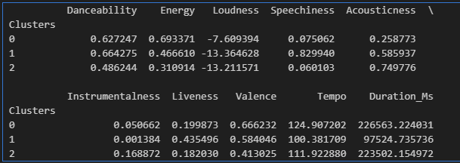

Optimal clutter Using Elbow Method :
Here I tried many values to k like, 1 to 9 and getting inertia values(WCSS) within the cluster sum of squares.
  - Elbow method is Graph of distortion score WCSSvs k
  - It is looking like elbow
  - Increase the number of clusters decreasing WCSS
  - 3 is the optimal cluster for this dataset.

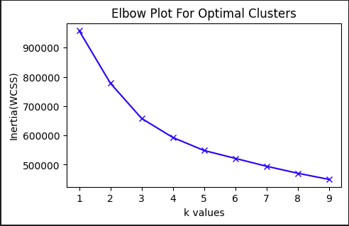
Here we can see after 3 there is no sharp decrease. K = 3 is the optimal cluster
METHODOLOGY ⚓:
KMeans, DBSCAN, Hierarchical (Aggolomerative)
KMeans Clustering 👍:
- Identified optional cluster using Elbow plot
- Three(3) is the optimal cluster for the given data set
- Finally We clustered the data, like chill Acoustic, Rap and Live, Energy and high danceability songs.
- Silhoustics score is 0.24 is very low performance in this dataset, indicates overlapping clusters

DBSCAN Clustering 💹:
- Identified outliers
- In this case no need to specified clusters
- Model automatically founded by itself
- Given eps = 2.3, min_samples = 5
Hierarchical Clustering(Agglomerative) 📊 :
- Here we used linkage ‘ward’ method
- Drawn Dentrogram like tree kind of structure
- Dengrogram is bottom to top approach

Model_Deployment🌐:
- 10 input Features taken by the user
- Then those inputs are Scaled and given to the model
- Model is predicted which type of cluster Based on the user input
Cluster 0 → "Energetic Dance Tracks"
Cluster 1 → "Balanced Vocal Songs"
Cluster 2 → "Calm Acoustic"

Finally the input Features colored by red color with existing Scatter plot

